enhancement of the features of the app ,

developer prespective - ui features

the landing page has to be made dynamic

a separate my orders page , wishlist , order tracking facilities

the user has to be notified that he placed the order via gmail or message - pending

payment intergration in teh app

in add the products page like there can be mechanisms like for the category selection there can be drop down of the already existing available categories or the new category addition ,

when the seller needs to add the product then he can add an image not the url because it would be difficult for him to add the url ryt because he has to host it and then add - instead what can we like do is we can ask him to take specific image like the resolution or something and then size because to avoid bad images in our website

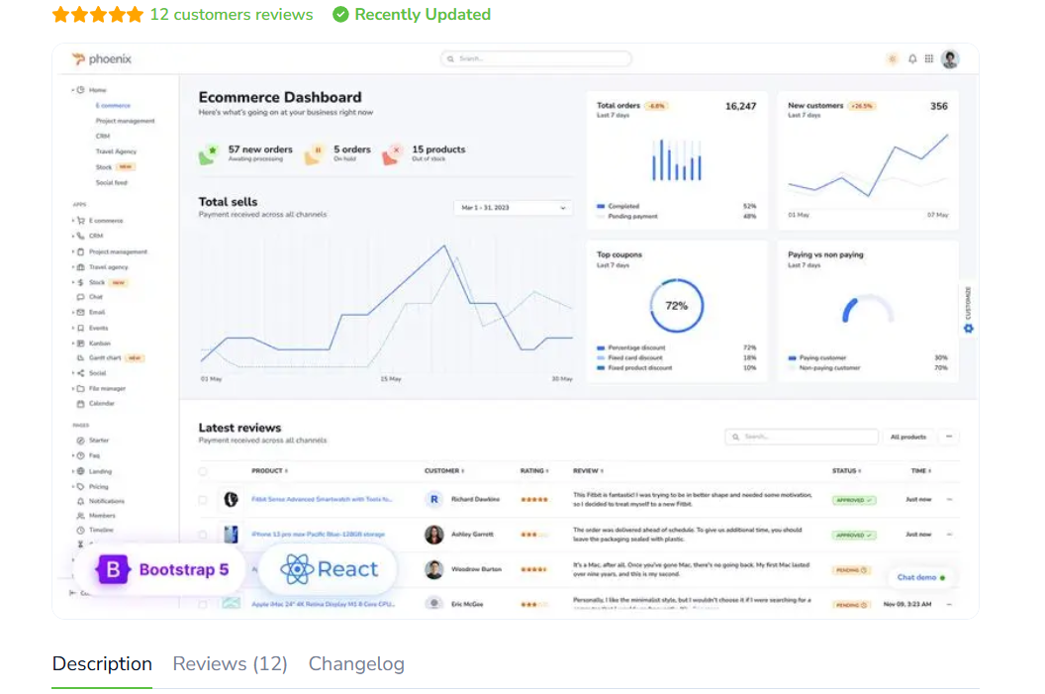

I need this kind of dashboard .
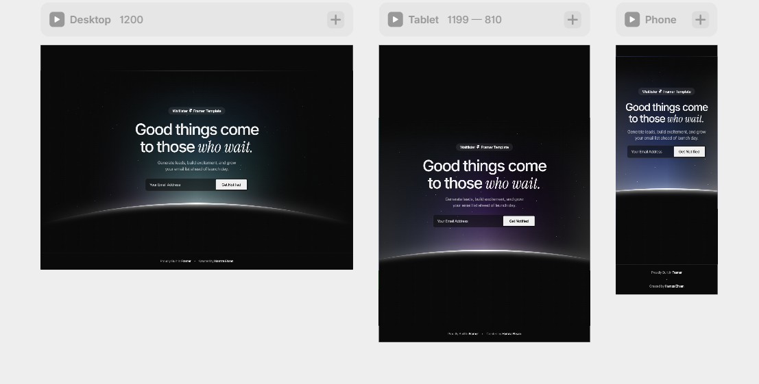 landing page template

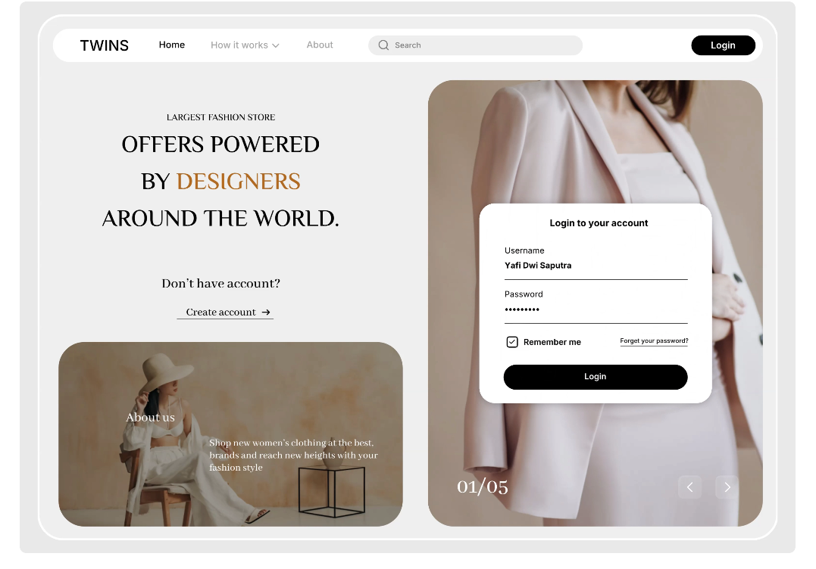

_{this kind of login page}
